DAY 3 CLASSWORK

19.Write a program to count the number of occurrences of a character in a string using pointers.

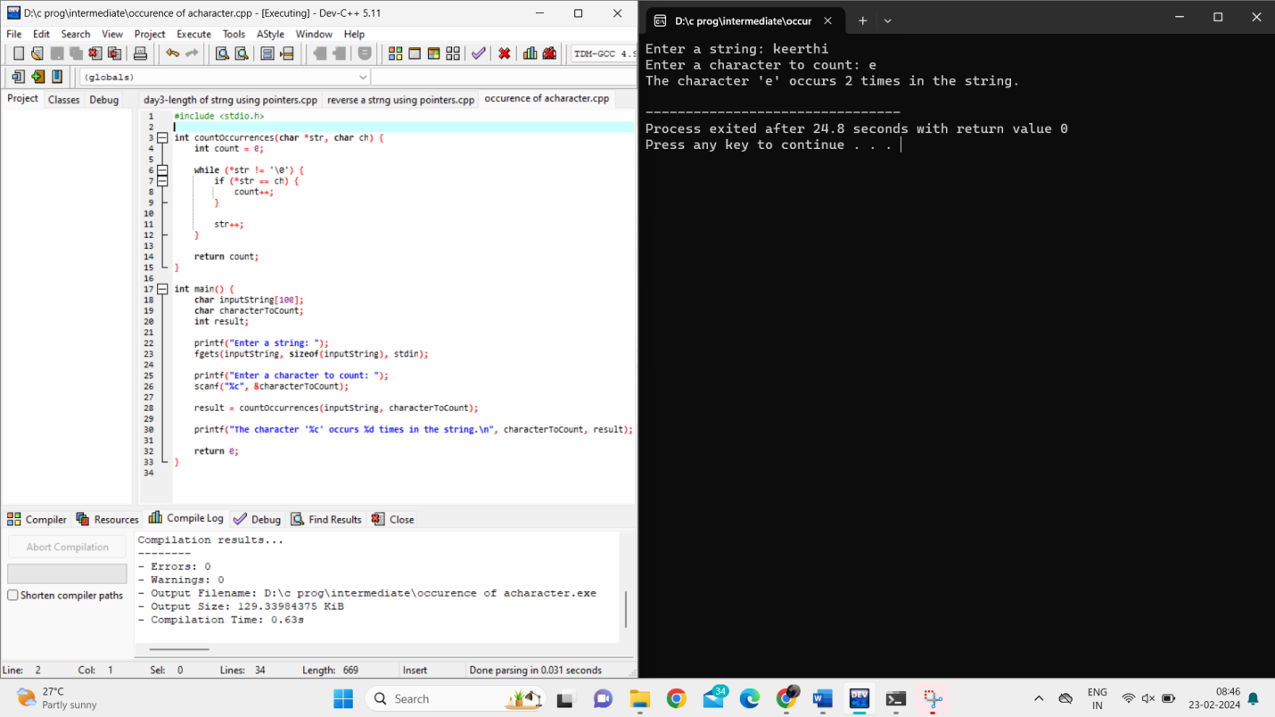

20.Write a program to find the maximum and minimum values in an array using pointers.

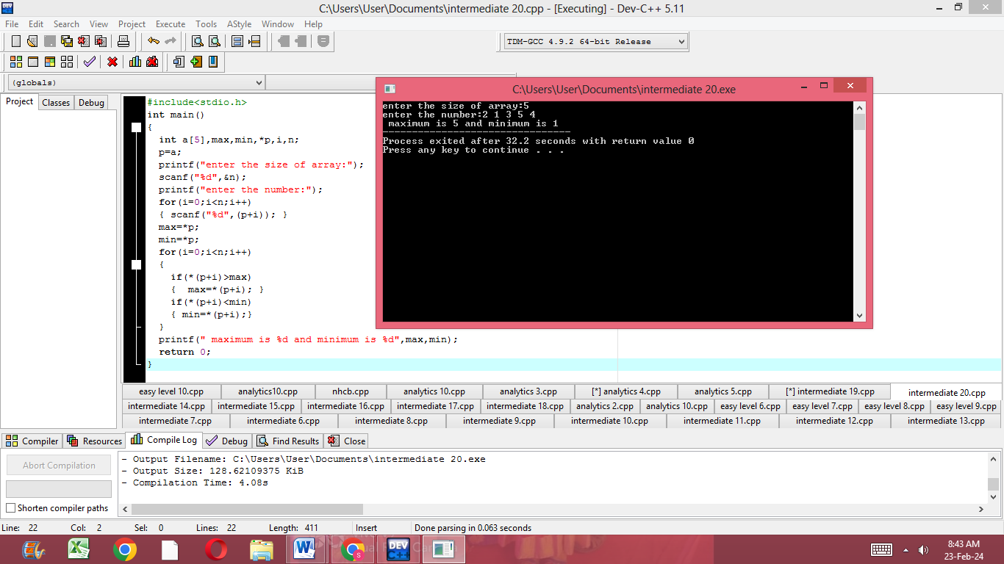

21.Write a program to sort an array of integers in ascending order using pointers.

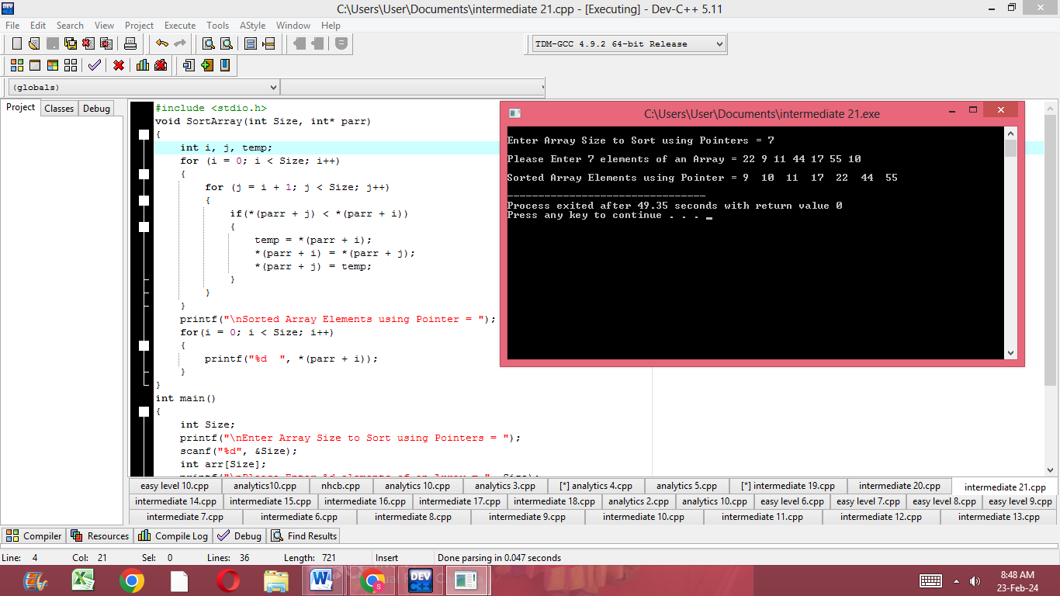

22.Write a program to find the factorial of a number using pointers.

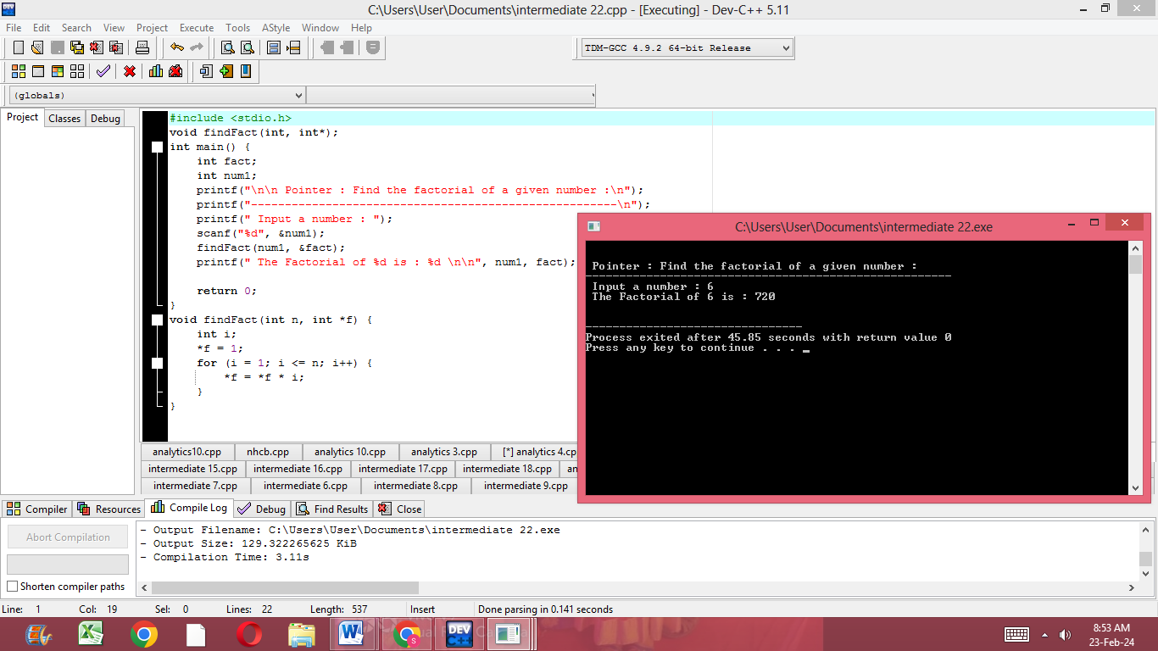

23.Write a program to check if a given number is prime using pointers.

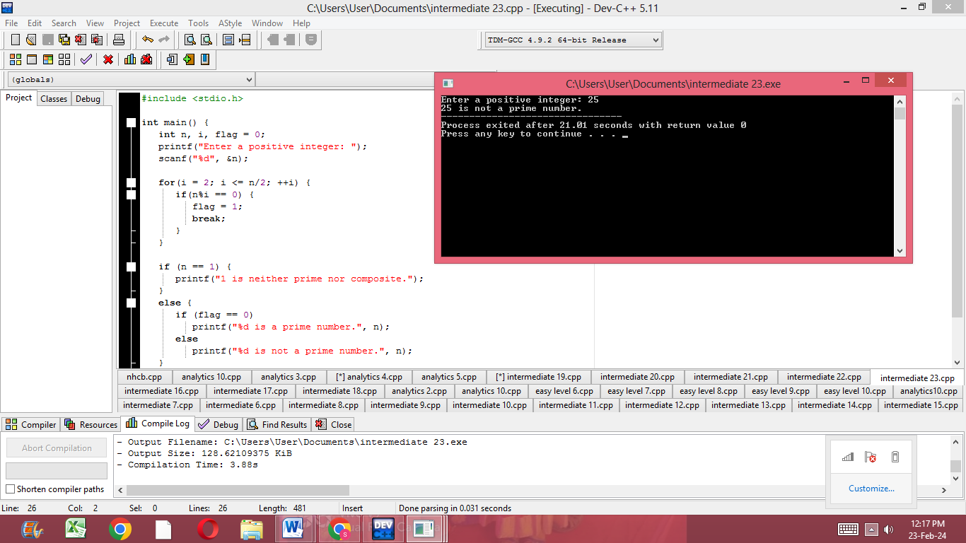

DAY 3 ANALYTICS:

13.Write a C program to implement a function that finds the length of the longest substring containing only distinct characters.

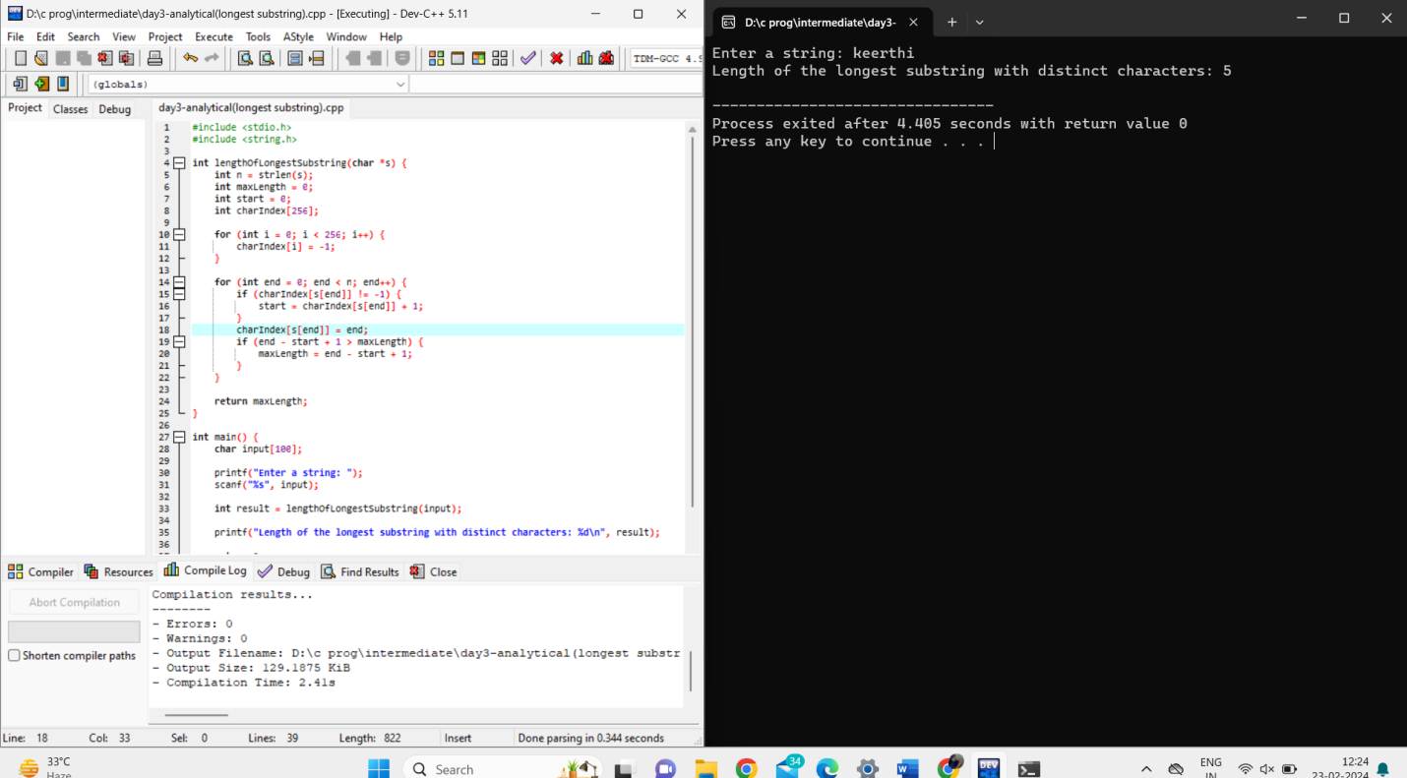

14.Write a C program to implement a function that finds the kth largest element in an unsorted array.

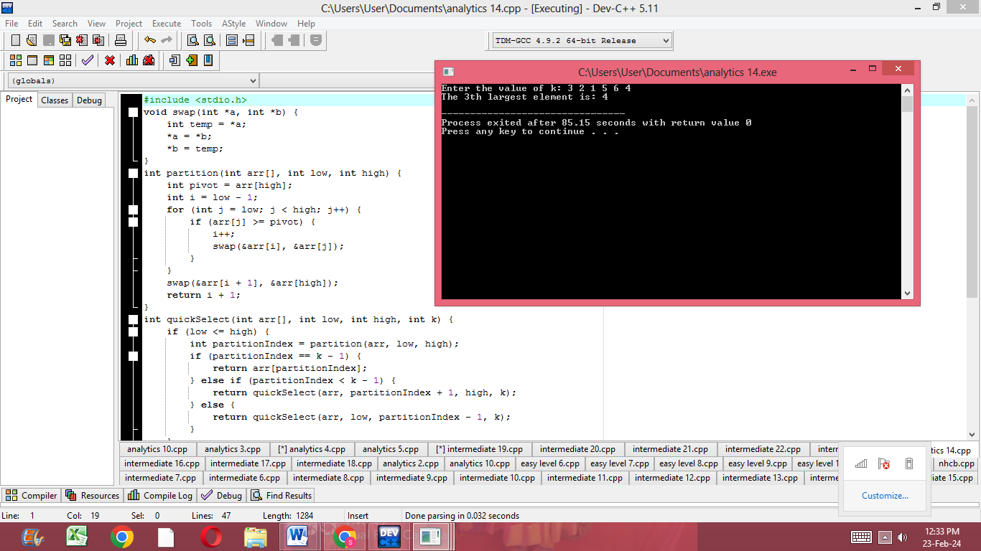

15.Write a C program to implement a function that finds the maximum sum subarray within a circular array (the circular array can be considered as a circular queue).

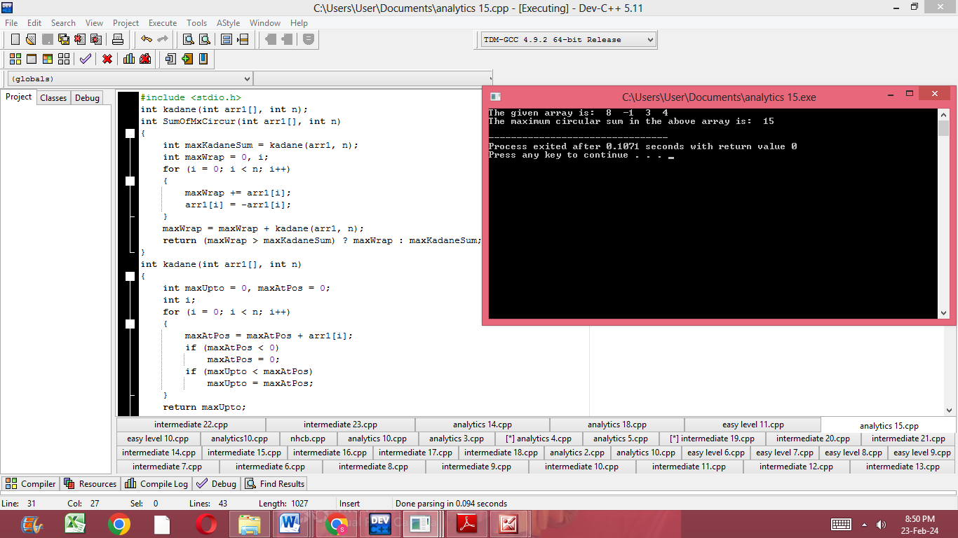

16.Write a C program to implement a function that finds the longest palindromic substring in a given string.

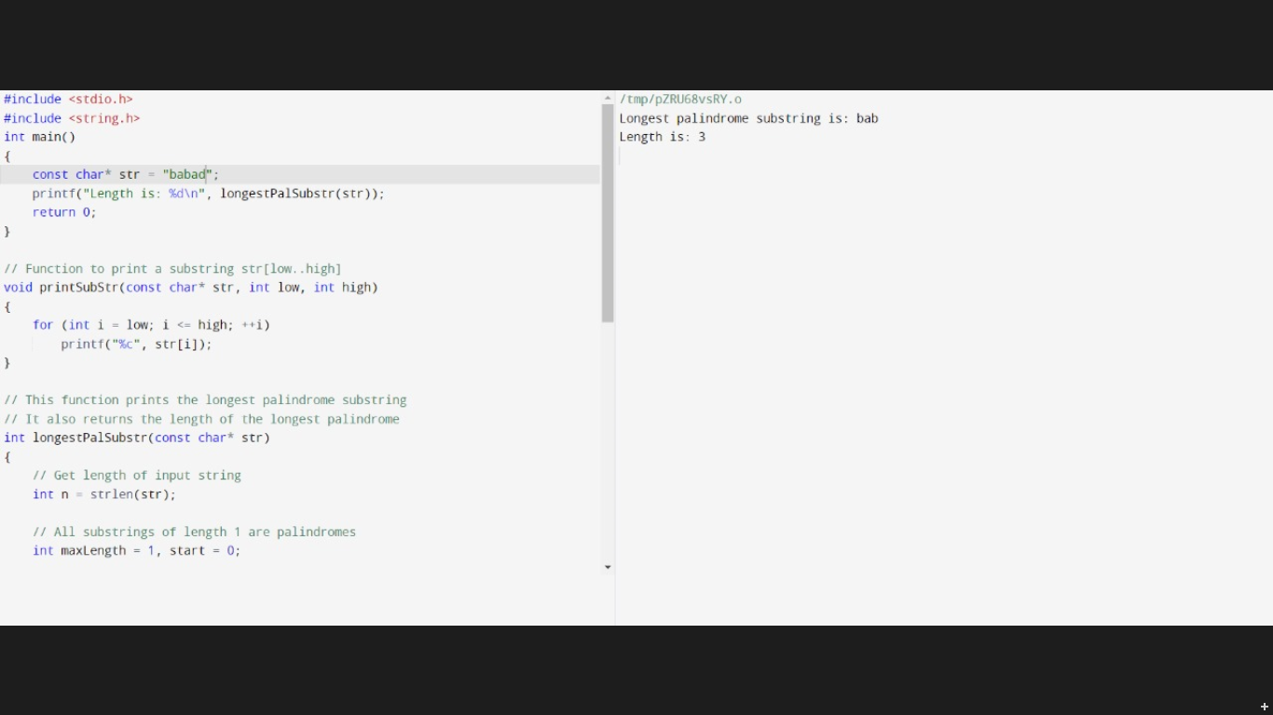

17.Write a C program to implement a function that counts the number of subarrays with sum less than a given value.

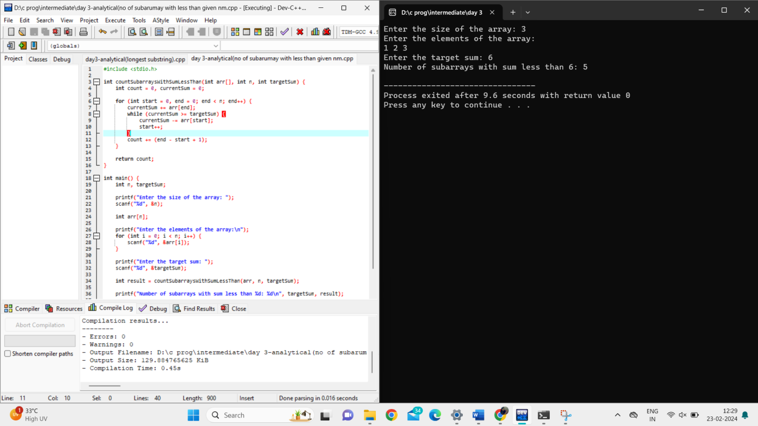

18.Write a C program to implement a function that returns the count of distinct substrings of a given string.

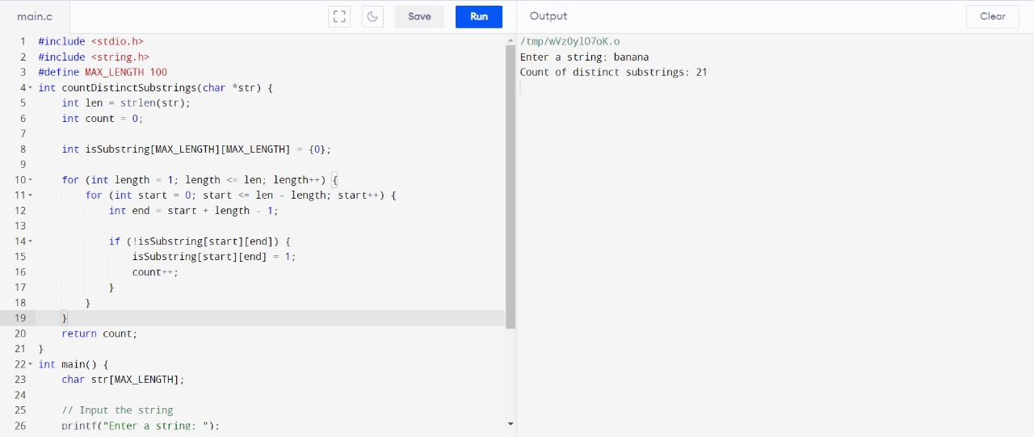

19.Write a C program to implement a function that returns the minimum window substring from a given string containing all the characters of another string.



20.Write a C program to implement a function that returns the length of the longest contiguous increasing subarray in a given array of integers.

